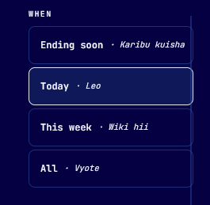
- Add tab called ‘NEW’
NEW – This defines as all the newly generated polls can be found easily.

- Add a history tab so that players can check their polls they played. Makes follow up easier for players.
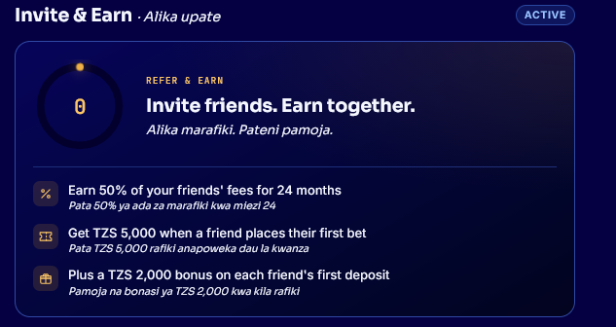
- This we should remove and have only earnings that is
- Get 10,000 TZS when a friend places their bet
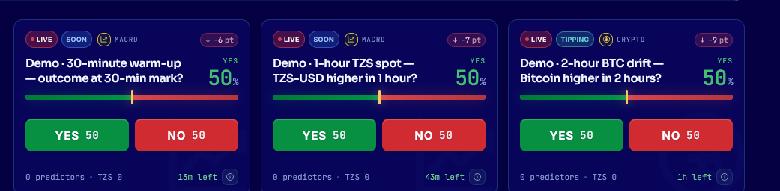
- Remove the demo polls

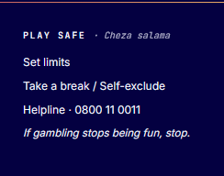
- Add msaada@50pick.co.tz in the helpline

